Grain protein goals within reach
CLAIRE HARRIS 28 Sep 2019, 6:03 p.m. 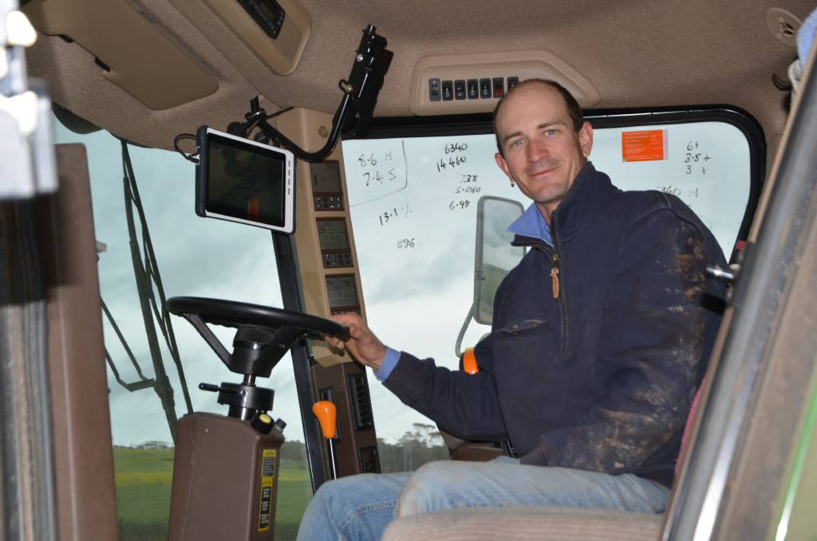

CROPPING DECISIONS ASSISTED:

Ben Francis, Loudounbrae Farming, Maitland, had a Cropscan 3300H On Combine Analyser installed on his header last year.

For Maitland cropper Ben Francis, the potential benefits of mounting a grain analyser on his header are "mind-blowing".

Mr Francis runs Loudounbrae Farming along with wife Jaymee and parents Roger and Kaye, and runs a rotation of wheat, barley, lentils and canola. He installed a Cropscan 3300H On Combine Analyser on his 9670 John Deere STS header before harvest last year, and says the valuable tool to help make decisions about applying fertiliser at a variable rate.
The analyser measures protein, oil and moisture content in grains and oil seeds as they are collected off the clean grain elevator every seven to 12 seconds.
By passing a known amount of light through the sample, the transmitted light is collected by a fibre-optic cable and sent to a near infrared spectrometer inside the cabin, where the protein, oil and moisture data is displayed in real time.
Mr Francis has been using Farmers Edge as a management tool for normalised difference vegetation index variable rate applications and collaborating collected cropping data since 2016, and said using a grain analyser was the next logical step to best utilise the yield maps.
"We had been applying variable rate nitrogen for a few years and needed another way of measuring if we had made correct decisions," he said. "Yes, we had a yield map, but what really matters to us is what that yield related to in regards to what the crop is doing."
Mr Francis was able to use last year's data to blend grain off the header to help reach his protein target of 10.5 per cent for APW, but said he had not made any major decisions regarding variable rate fertiliser for his crops.
There are operations out there which have had grain analysers for a couple of years and are making some phenomenal decisions out of them - I want to get to that point.

"You can't base (decisions) off one year of data, we're still at that point in time where we'll be just accumulating and correlating data for the next couple of years," he said.
But Mr Francis said the accumulated data would assist him to make sure his crops were nutritionally balanced.
"If I want to harvest grain with a H2 (receival standard), we can apply fertiliser to achieve that, if we want APW, we can iron kinks out that we're seeing across paddocks to achieve that," he said.
"We want to realise our full yield potential, and quality.
"For example, if we have a high yielding area of a crop with a low protein content, I'd apply more nitrogen to that area."
Mr Francis said the moisture reading was another major benefit of the analyser, having wanted to collect moisture readings for years, but "holding off" until he could install a device on the header.
"I have to reap a sample to find out what the moisture is, so why not have that on the header?" he said.
The ability to create instant maps while harvesting, with data showing bin and field averages, was another bonus, Mr Francis said.

NEW TOOL OFFERS MULTIPLE BENEFITS
MAITLAND cropper Ben Francis said while data collected by his Cropscan 3300H On Combine Analyser would help him make decisions about nitrogen fertilisers in the future, the analyser would influence decisions regarding all major inputs.
"If we're getting our protein on par and a yield increase because we're not overfeeding or under feeding, it'll have other spin-off benefits, in regards to applications of trace elements and phosphorus and other inputs," he said.
"There are operations out there which have had grain analysers for a couple of years and are making some phenomenal decisions out of them - I want to get to that point."

Decisions made early in season to cut for hay

The accuracy and frequency of data collecting was an appealing feature of the tool, Mr Francis said.
"This is to the quality that the silo will sample at, and it's happening about 10 times a minute," he said.
He said the analyser was used on all his crops, and was relatively hassle free.
"With canola we have to stop every couple of hours to clean the sensor head quite a bit, but we only have to clean it once a day with wheat and barley."
He said he "didn't have to get much right" for the benefits to outweigh the capital costs.
"For the money you pay for it compared to what we could potentially get out of it, is mind-blowing," he said. "It's as good as what you calibrate it to. Once you have a calibration level you're happy with, it's pretty much right from year to year."

